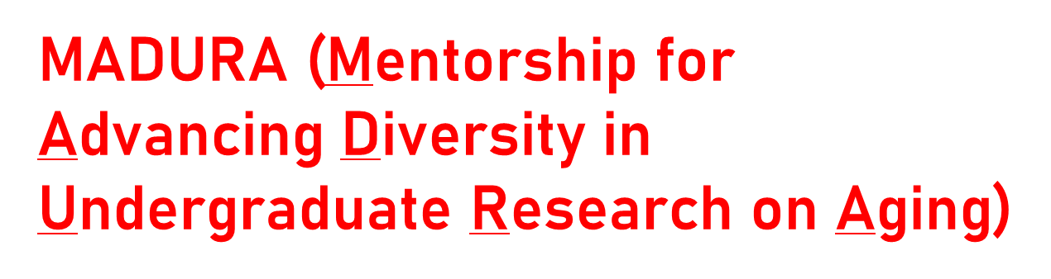
Faculty Researchers:

Funding for Undergraduate Research Mentees Available

is an Advancing Diversity in Aging Research (ADAR) training program at UC San Diego
Steven Edland & Dennis Trinidad - mPIs Becky Marquez & Guerry Peavy - Co-Investigators
National Institute of Aging: 1 R25 AG066594
For whom? Undergraduates from groups historically underrepresented in health and STEM majors, and/or from disadvantaged backgrounds.
Students must have a genuine interest in careers in aging and/or Alzheimer’s Disease research or clinical care, and a minimum 3.0 G.P.A.
Why? To increase diversity and inclusion in aging or Alzheimer’s research, and among future researchers and clinical care providers.
To increase Alzheimer’s Disease/Related Dementias and aging-focused graduate and medical program applications by underrepresented students.
How? Our Program provides weekly Faculty-led Group Mentorship, Training and Supervision, and pays participating trainees to work 8 hours/ week at approved research placements across campus.
Studies can be lab-based, interventions, epidemiological, health promotion, etc… Students are placed for Fall/Winter/Spring quarters (excludes Summers).
MADURA continues to support students in good standing for the duration of their undergraduate careers.
Please contact us, if you would like to discuss a MADURA Program trainee working on your project(s) 8 hours/week, with MADURA Program-provided pay, weekly support and training! --- Sheri Thompson, Program Coordinator

