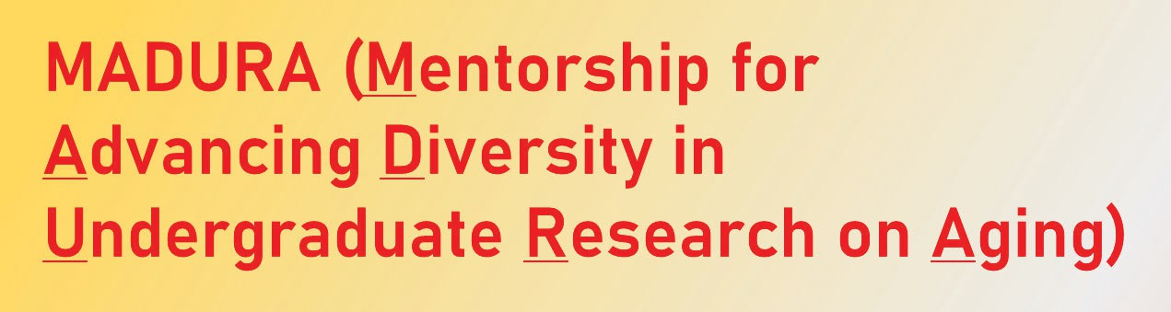
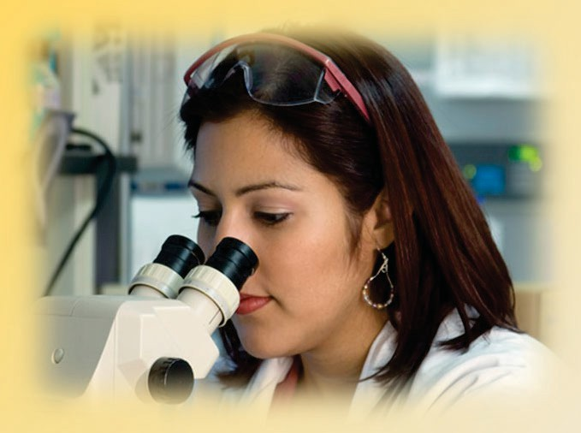
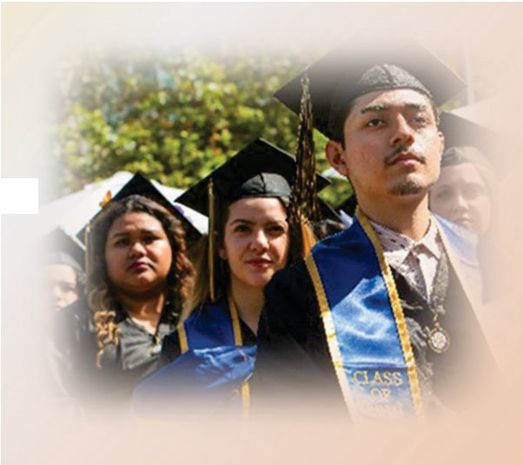
National Institute of Aging: 1 R25 AG066594 (Steven D. Edland, PI)
UC S AN D IE GO U NDERGRADS F ROM P OPUL AT IO S
NS
U N DERREPRE S E N T E D I N M EDICAL O R S T EM CAREER S ,
S
OR DISAD VAN TA GE D P OPUL AT IONS :
Are you interested in Aging or Alzheimer’s Disease Research?
Are you an MSTEM (Medical, Science, Technology, Engineering or
Mathematics) major?

We have a Paid Training Opportunity for you to consider!

To 1' Academic success and graduation rates
To 1' Alzheimer’s Disease/Related Dementias (AD/RD) and Aging-related graduate or medical school applications
D)
To 1' diversity in Aging and AD/RD research & clinical careers

How? MADURA is both a training program and a job. Trainees receive Faculty-led mentorship & research training, and pay to work with a Research Mentor at Aging or AD/RD approved placements. Students are paid
$15.55/hour for a 10 hour/week commitment (Fall/Winter/Spring quarters).

Placements are based at main and medical Campus labs and research offices. Depending on the student’s major and nature of the study, research activities may include assisting with wet lab experiments, participant recruitment, screening, materials development, data entry, intervention implementation, literature reviews, health promotion or educational outreach, conducting clinical trials, and more.

IMPORTANT DATES
Student Application forms for 2023/2024 are now closed.
Most placements are filled for Fall quarters – but *if* there are relevant openings for Winter or Spring quarters, you will be contacted by email and invited to interview.
Other notes: All placements are contingent upon attending in-person, mandatory Group Mentorship meetings from 2:00-4:00 PM on every Friday during the Quarter. Please do not apply unless you are available and committed to this Group training opportunity.
The application window for the 2024-2025 academic year will be May 1st to July 1st, 2024. Please check back for link then.
Questions? Please contact MADURA Program Coordinator, Sheri Thompson, PhD at the email below.

MADURAprogram@health.ucsd.edu Website: https://MADURAprogram.ucsd.edu

